TP tracking: https://lt2.boliga.dk/tjek-prisen

Step 1 – dataLayer event (NEW!):

<script>
window.dataLayer = window.dataLayer || [];
dataLayer.push({
'event':'check_price_step1_check_price',
'address':'Skovvej 1, 2635 Ishøj', // the searched address
'zipcode':'2635', // the zipcode from the searched address
'price_estimate':'1500000' // the automatically estimated price
});
</script>

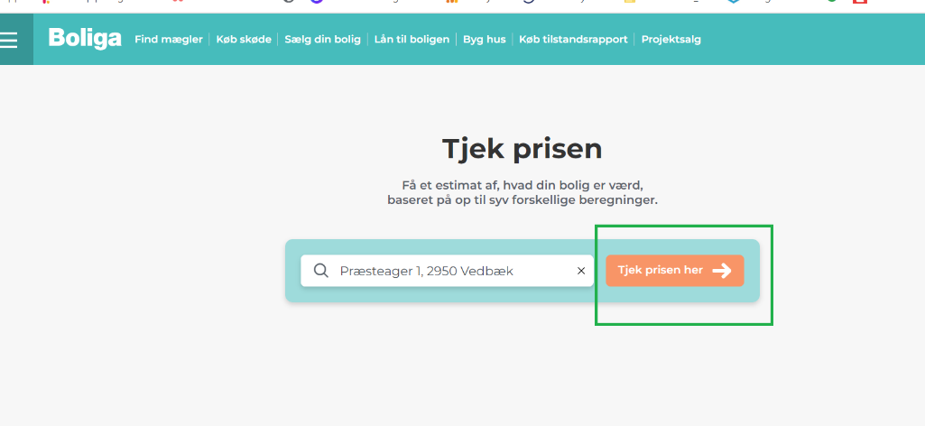

Step 2 – dataLayer event (NEW!):

<script>
window.dataLayer = window.dataLayer || [];
dataLayer.push({
'event': 'check_price_step2_get_free_appraisal',
'address': 'Skovvej 1, 2635 Ishøj', // the searched address
'zipcode': '2635', // the zipcode from the searched address
'price_estimate': 1500000 // the automatically estimated price in DKK (without decimal point or thousand divider)
});
</script>

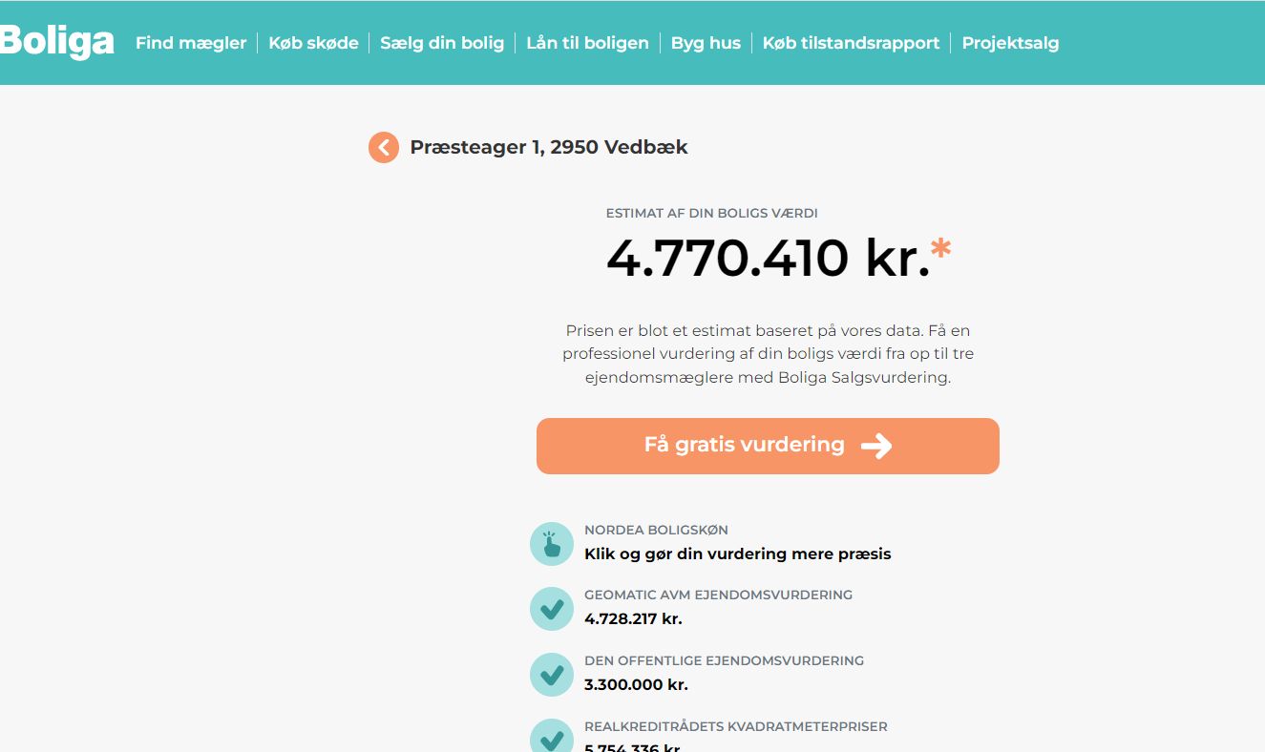

SV tracking: https://lt2.boliga.dk/bestil-salgsvurdering

Step 1 (USE THE SAME)

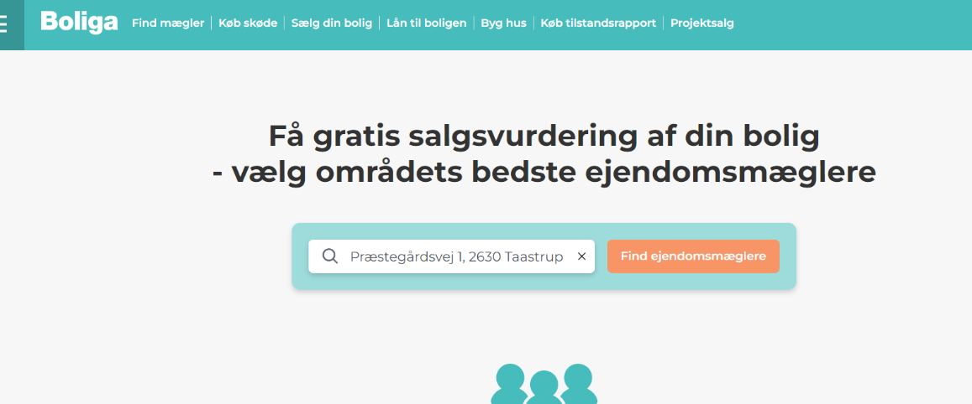

<script>
window.dataLayer = window.dataLayer || [];
dataLayer.push({
'event':'broker_leads_enter_address_next',
'address':'Skovvej 1, 2635 Ishøj', // the searched address
'zipcode':'2635' // the zipcode from the searched address
});
</script>

Step 2 (NEW DATALAYER):

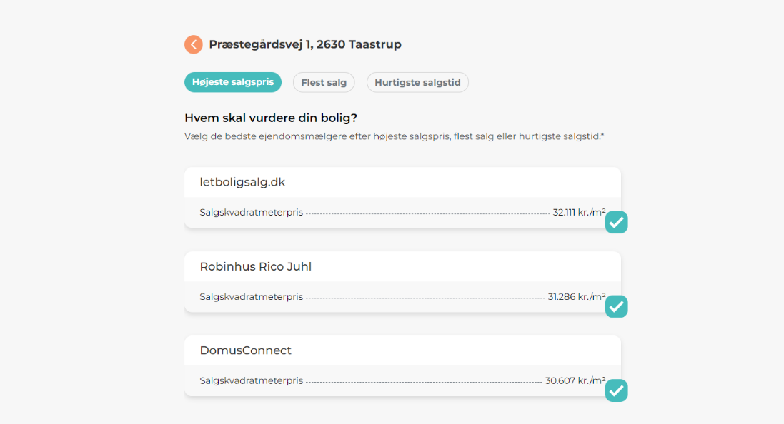

<script>
window.dataLayer = window.dataLayer || [];
dataLayer.push({
'event': 'broker_leads_get_contacted_order_completed',
'address': 'Skovvej 1, 2635 Ishøj',
'zipcode': '2635',
'price_estimate': 1500000, // if available from check price: set to the automatically estimated price in DKK (without decimal point or thousand divider). If not available (if the user did not come from check price) set to null
'broker_lead_1': 'Nybolig Mariann Trolledahl Vallensbæk-710',
'broker_lead_2': 'home Vallensbæk-21',
'broker_lead_3': 'RealMæglerne Vallensbæk ApS-24047'
});
</script>

